Student worksheet

4.1 Resources on Earth are either renewable or non-renewable

Pages 62–63

Renewable and non-renewable resources

1 Examine the images of different environmental resources. Write what type of resource it is and a brief overview of the resource.

|  |  |  |
| --- | --- | --- |
| Resource image | Type of resource | Overview of the resource |
| L:\1. Publishing and Editorial\1. Product\Oxford Science\Oxford Science 7\3. Extras\7. Student worksheets\Artwork\4. Final jpgs\from Perms\Edited artwork from Julia\Chapter 4\JPEGs\WS0409A_00883-r.jpg |  |  |
| L:\1. Publishing and Editorial\1. Product\Oxford Science\Oxford Science 7\3. Extras\7. Student worksheets\Artwork\4. Final jpgs\from Perms\Edited artwork from Julia\Chapter 4\JPEGs\WS0410_00883-r.jpg |  |  |
| L:\1. Publishing and Editorial\1. Product\Oxford Science\Oxford Science 7\3. Extras\7. Student worksheets\Artwork\4. Final jpgs\from Perms\Edited artwork from Julia\Chapter 4\JPEGs\WS0411_00883-r.jpg |  |  |
| L:\1. Publishing and Editorial\1. Product\Oxford Science\Oxford Science 7\3. Extras\7. Student worksheets\Artwork\4. Final jpgs\from Perms\Edited artwork from Julia\Chapter 4\JPEGs\WS0412_00883-r.jpg |  |  |
| L:\1. Publishing and Editorial\1. Product\Oxford Science\Oxford Science 7\3. Extras\7. Student worksheets\Artwork\4. Final jpgs\from Perms\Edited artwork from Julia\Chapter 4\JPEGs\WS0413_00883-r.jpg |  |  |
| L:\1. Publishing and Editorial\1. Product\Oxford Science\Oxford Science 7\3. Extras\7. Student worksheets\Artwork\4. Final jpgs\from Perms\Edited artwork from Julia\Chapter 4\JPEGs\WS0414_00883-r.jpg |  |  |

2 Environmental resources can be classified as renewable and non-renewable. Classify the following items by thinking about which environmental resource they originally came from (e.g. paper products came from forests, therefore are renewable resources).

a Petrol for your family car: \_\_\_\_\_\_\_\_\_\_\_\_\_\_\_\_\_\_\_\_\_\_\_\_\_\_\_\_\_\_\_\_\_\_\_\_\_\_\_\_

b A cardboard box: \_\_\_\_\_\_\_\_\_\_\_\_\_\_\_\_\_\_\_\_\_\_\_\_\_\_\_\_\_\_\_\_\_\_\_\_\_\_\_\_

c The wind that turns a turbine: \_\_\_\_\_\_\_\_\_\_\_\_\_\_\_\_\_\_\_\_\_\_\_\_\_\_\_\_\_\_\_\_\_\_\_\_\_\_\_\_

d Soil that is in your garden: \_\_\_\_\_\_\_\_\_\_\_\_\_\_\_\_\_\_\_\_\_\_\_\_\_\_\_\_\_\_\_\_\_\_\_\_\_\_\_\_

e The coal that provides electricity: \_\_\_\_\_\_\_\_\_\_\_\_\_\_\_\_\_\_\_\_\_\_\_\_\_\_\_\_\_\_\_\_\_\_\_\_\_\_\_\_

f Water that you drank yesterday: \_\_\_\_\_\_\_\_\_\_\_\_\_\_\_\_\_\_\_\_\_\_\_\_\_\_\_\_\_\_\_\_\_\_\_\_\_\_\_\_

g The fertiliser that was used on a farm: \_\_\_\_\_\_\_\_\_\_\_\_\_\_\_\_\_\_\_\_\_\_\_\_\_\_\_\_\_\_\_\_\_\_\_\_\_\_\_\_

h Gold that is in a necklace or earring: \_\_\_\_\_\_\_\_\_\_\_\_\_\_\_\_\_\_\_\_\_\_\_\_\_\_\_\_\_\_\_\_\_\_\_\_\_\_\_\_

i Geothermal energy from the Earth: \_\_\_\_\_\_\_\_\_\_\_\_\_\_\_\_\_\_\_\_\_\_\_\_\_\_\_\_\_\_\_\_\_\_\_\_\_\_\_\_

j A plastic wrap you had your lunch in: \_\_\_\_\_\_\_\_\_\_\_\_\_\_\_\_\_\_\_\_\_\_\_\_\_\_\_\_\_\_\_\_\_\_\_\_\_\_\_\_

3 How is the Sun’s energy linked to:

a water as a renewable resource?

b plants as a renewable resource?

EXTEND YOUR UNDERSTANDING

4 Even though forests are renewable resources, if the trees that are logged are not replaced, either naturally or by humans, the forest resource may become non-renewable in some places.

a What are the top five countries with the most amount of forest.

b What are the top five countries with the most amount of cleared forest.

c Is there a relationship between these two statistics?

Student worksheet

4.2 Renewable resources can be quickly replaced

Pages 64–65 and 186

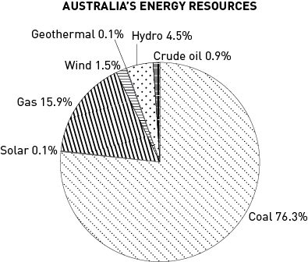Replaceable resources

1 The pie chart shows the use of Australia’s energy resources.

a Rank the energy resources from highest percentage use to the lowest.

b List the energy resources that are from renewable energy sources.

c What is the total percentage of Australia’s energy that comes from renewable resources?

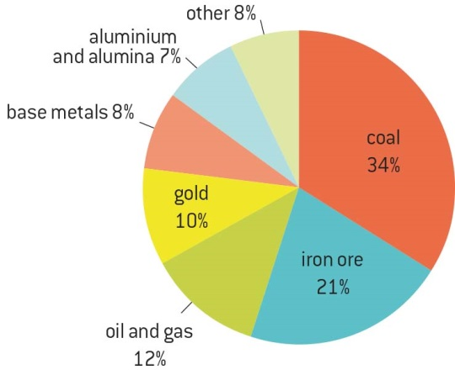

**AUSTRALIA’S MINING EXPORTS, 2009**

d Australia is one of the highest greenhouse gas emitters in the world. How do you think Australia’s mining exports contribute to greenhouse gas emissions in other countries of the world?

2 Using the map of Australia on page 65 of the textbook, answer the following questions:

a Where in southern parts of Australia are most of the wind power stations found?

b Why do you think the wind power stations are found on the coast or offshore in the southern parts of Australia?

c Where in Australia are most of the coal energy resources found?

d Natural gas resources are found in many different parts of Australia. Name one place where natural gas resources are located in the following states and territories:

i Northern Territory: \_\_\_\_\_\_\_\_\_\_\_\_\_\_\_\_\_\_\_\_\_\_\_\_\_\_\_\_\_\_\_\_\_\_\_\_\_\_\_\_\_\_\_\_

ii Western Australia: \_\_\_\_\_\_\_\_\_\_\_\_\_\_\_\_\_\_\_\_\_\_\_\_\_\_\_\_\_\_\_\_\_\_\_\_\_\_\_\_\_\_\_\_

iii Queensland: \_\_\_\_\_\_\_\_\_\_\_\_\_\_\_\_\_\_\_\_\_\_\_\_\_\_\_\_\_\_\_\_\_\_\_\_\_\_\_\_\_\_\_\_

iv Victoria: \_\_\_\_\_\_\_\_\_\_\_\_\_\_\_\_\_\_\_\_\_\_\_\_\_\_\_\_\_\_\_\_\_\_\_\_\_\_\_\_\_\_\_\_

v South Australia: \_\_\_\_\_\_\_\_\_\_\_\_\_\_\_\_\_\_\_\_\_\_\_\_\_\_\_\_\_\_\_\_\_\_\_\_\_\_\_\_\_\_\_\_

EXTEND YOUR UNDERSTANDING

3 Research why there is a cluster of hydro power stations near the Snowy Mountains around the border of Victoria and New South Wales. Present your findings as a combination of images and text on a single piece of paper.

a When and why were these hydro power stations built?

b How big is the hydro power stations project?

c How do the hydro power stations create energy?

d Were there any problems or difficulties during the construction of the hydro power stations?

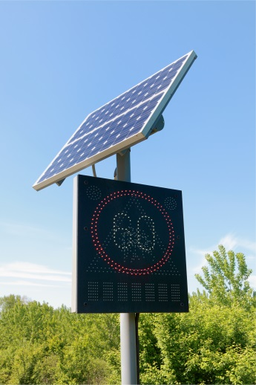Student worksheet

4.3 Renewable resources can be harnessed to provide energy

Pages 66–67 and 188

Renewable energy

1 Renewable energy sources have both advantages and disadvantages for the environment. The advantages tend to be on a global scale, but the disadvantages are often in the local area. Fill in the table below to explore this further.

|  |  |  |
| --- | --- | --- |
| Renewable resource | Advantages | Disadvantages |
| Wind energy |  |  |
| Solar energy |  |  |
| Geothermal energy |  |  |
| Hydroelectric energy |  |  |
| Tidal energy |  |  |

2 The various renewable energy resources provide power that can be used as an alternative to burning fossil fuels, but have you experienced this energy? Describe how you can or have experienced the power from renewable energy resources; for example, you may describe visiting the hot springs in New Zealand as an example of how you experienced geothermal energy.

a The power of the wind

b The power of the Sun

c The power of the waves or tides

d The power of flowing water

e The power of the Earth’s heat

EXTEND YOUR UNDERSTANDING

3 There are other renewable energy resources that are being used and developed to provide sustainable and environmentally friendly power for different places around the world. Find out a little more about the following renewable energy resources:

• Biomass

• Biofuel

• Biological hydrogen production

Student worksheet

4.4 Non-renewable resources are limited

Pages 68–69 and 189–190

Fossil fuels

1 Review your understanding of the formation of coal by describing what happens at each stage:

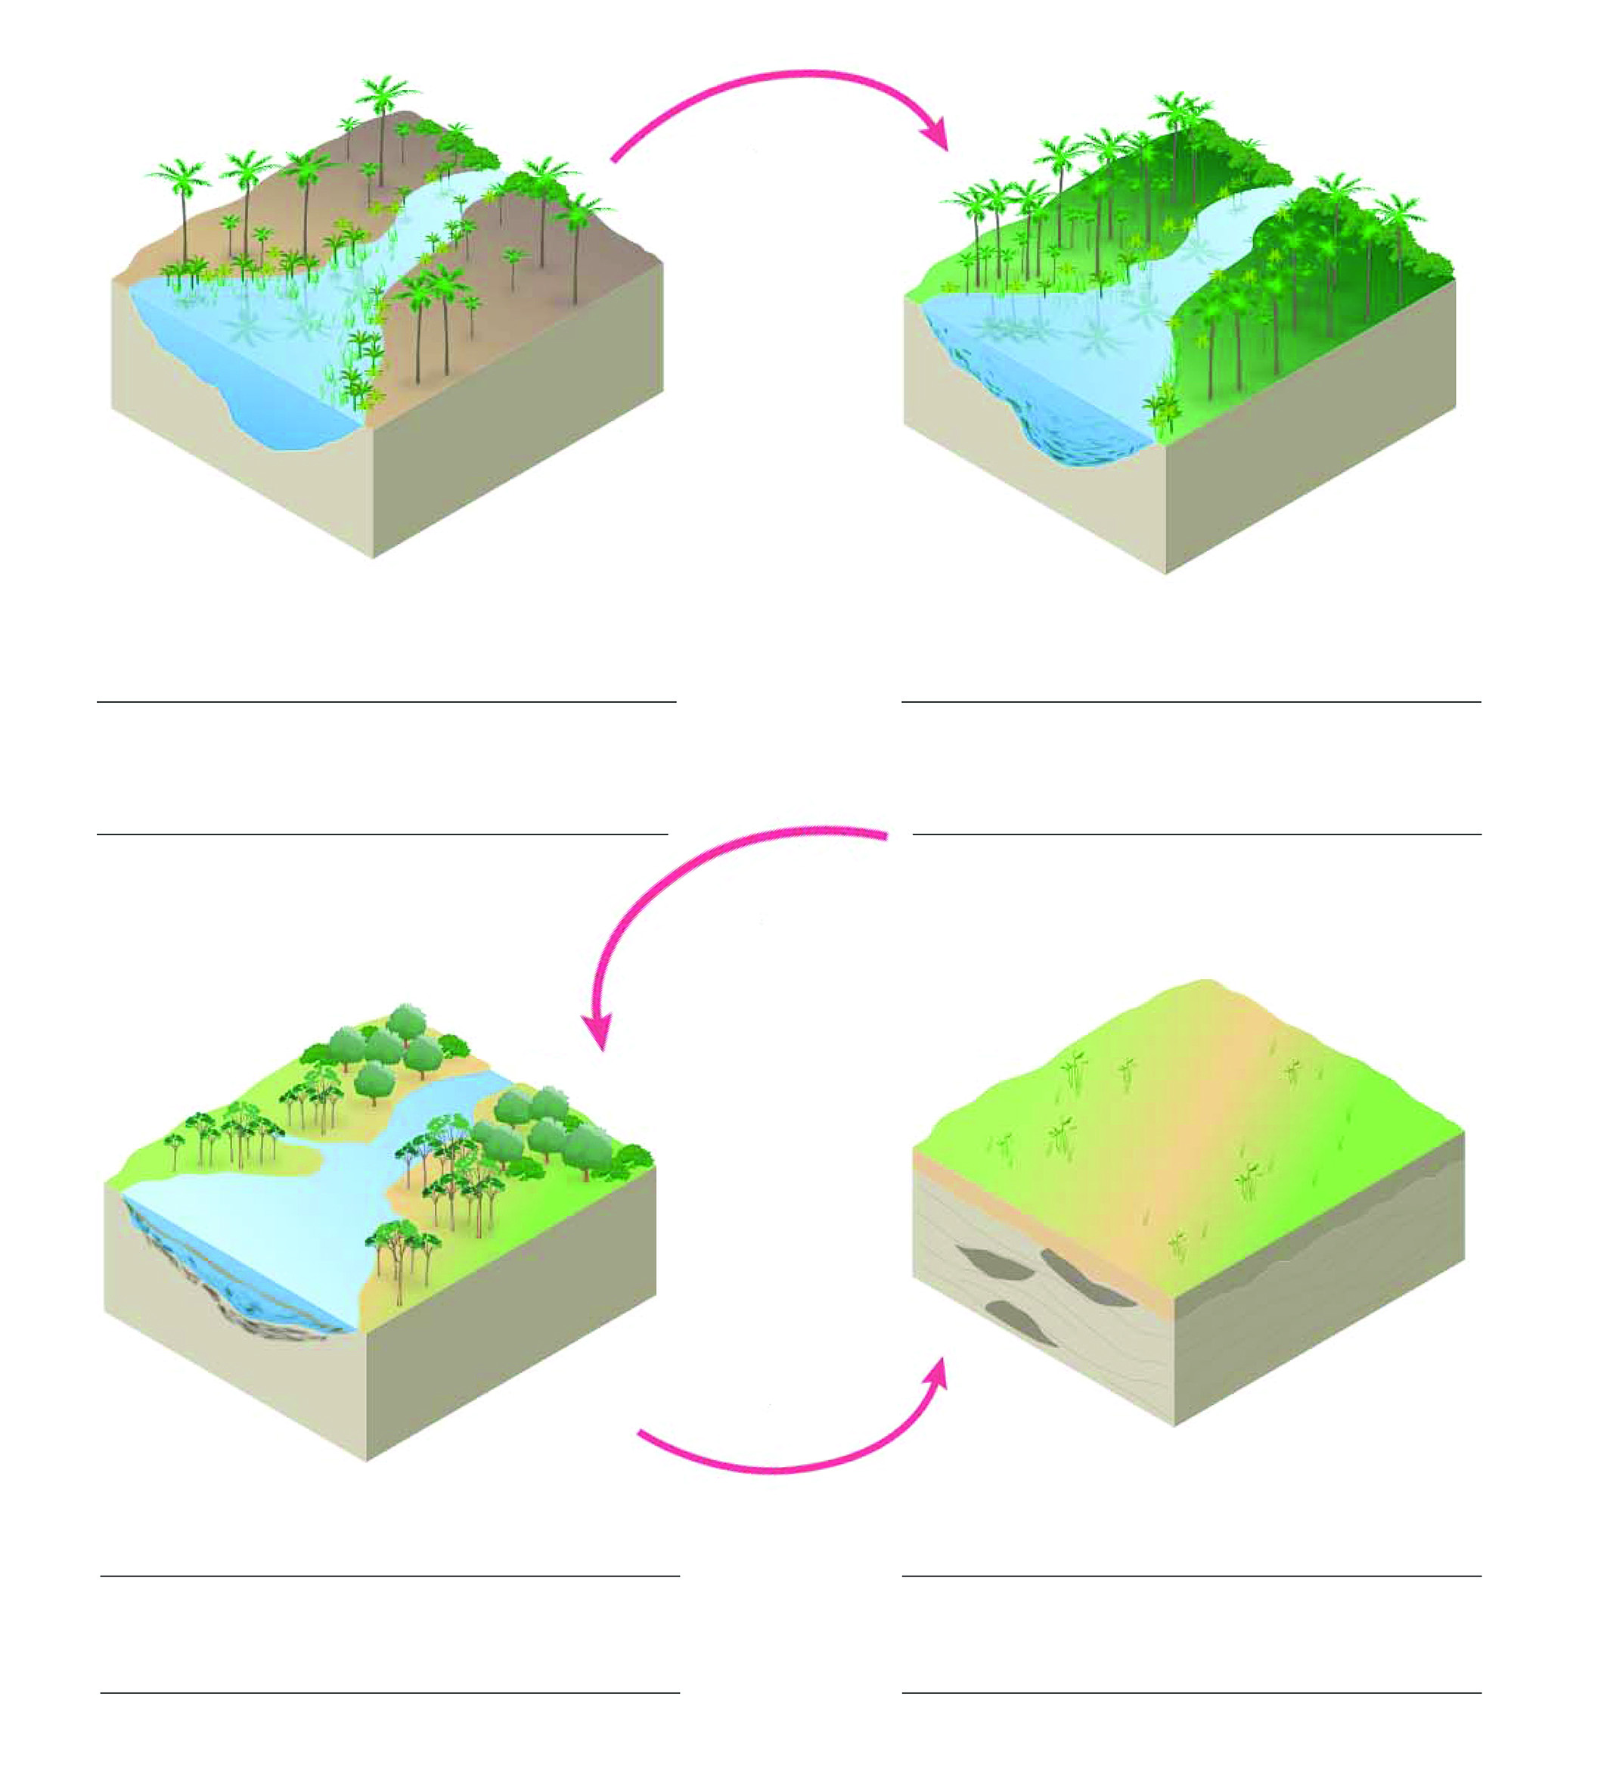

2 Draw a simple flow chart to explain how uranium is used to produce electricity.

3 Coal-fired power stations burn coal to produce electricity. When coal is burned, heat is used to boil water to make steam. The steam is used to make a turbine spin. The turbine is connected to a generator, which converts the movement from the turbine into electrical energy. How is this similar to the way electricity is produced by uranium?

EXTEND YOUR UNDERSTANDING

4 The mining of ore deposits can result in the extraction of small quantities of minerals from huge quantities of ores. Before you mine your muffin in the ‘What if a muffin were mined in different ways?’ experiment, include the following processes in your method. You will need a set of electronic scales.

a What is the weight the muffins before you start mining? \_\_\_\_\_\_\_\_\_\_\_\_\_\_\_\_

b What is the weight of the chocolate you extracted? \_\_\_\_\_\_\_\_\_\_\_\_\_\_\_\_

c Research whether this is similar to a typical yield of aluminium from bauxite mined at Weipa.

Student worksheet

4.5 Soil is one of our most valuable resources

Pages 70–71 and 191

Soil as a resource

1 What do you think is the difference between soil and dirt?

2 The diagram below is a soil profile, which shows the different layers in the top section of the soil.

a Use the following words to label the different layers of the soil profile:

• Small and larger rocks

• Grass and leaf litter

• Hard rock layer

• Humus

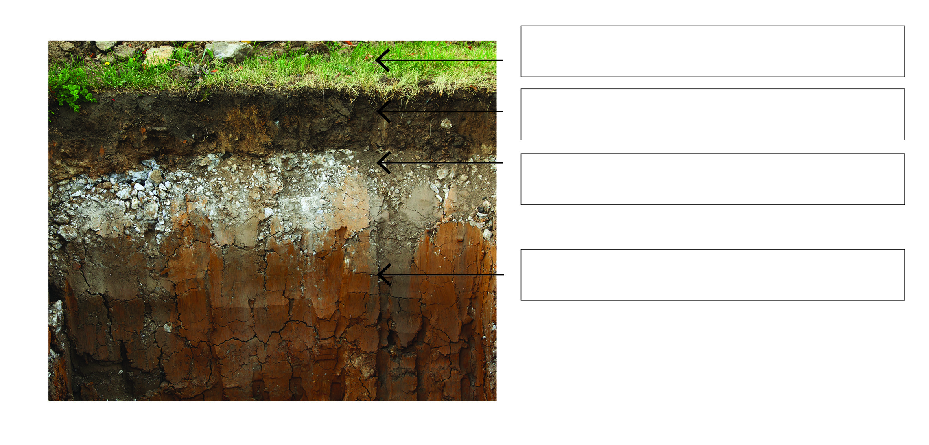

b Which layer of the soil would contain decomposed plants and animals?

3 What could you add to poor soil to make it healthy in the following examples?

a The soil is draining very quickly and drying out.

b The soil is lacking organic content.

c The soil is unhealthy because of a lack of organisms.

d The soil structure lacks nutrients.

e The soil is becoming waterlogged and muddy.

4 The farmland in the image below is suffering from severe erosion and the topsoil is very poor quality. What can the farmer do to improve this land?

**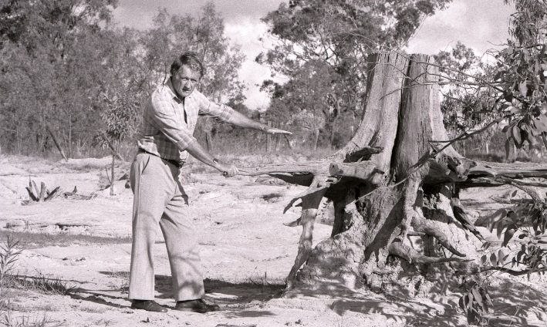**

EXTEND YOUR UNDERSTANDING

5 Examine the soil at or near your home. Complete ‘B What’s in soil?’ from Experiment 4.5 by using a soil sample and a jar from home. Compare this sample with the ‘good garden soil’ sample from the experiment and describe any similarities or differences.

Student worksheet

4.6 Our future depends on careful management of resources

Pages 72–73 and 192

Resource management

1 Complete the following sentences to revise the future of resources.

a LEVs are \_\_\_\_\_\_\_\_\_\_\_\_\_\_\_\_\_\_\_\_\_\_\_\_\_\_\_\_\_\_\_\_\_\_\_\_\_\_\_\_\_\_\_\_\_\_\_\_\_\_\_\_\_\_\_\_\_\_\_\_\_\_.

b Hybrids use a mix of \_\_\_\_\_\_\_\_\_\_\_\_\_\_\_\_\_\_\_\_\_\_\_\_\_\_\_\_\_\_\_\_\_\_\_\_\_\_\_\_\_\_\_\_\_\_\_\_\_\_\_\_\_.

c Ethanol is an abbreviation of \_\_\_\_\_\_\_\_\_\_\_\_\_\_\_\_\_\_\_\_\_\_\_\_\_\_\_\_\_\_\_\_\_\_\_\_\_\_\_\_\_\_\_\_\_\_\_.

d BlueGen fuel cells burn \_\_\_\_\_\_\_\_\_\_\_ \_\_\_\_\_\_\_\_\_\_ in an efficient \_\_\_\_\_\_\_\_\_\_ \_\_\_\_\_\_\_\_.

e Smart plugs will monitor \_\_\_\_\_\_\_\_\_\_\_\_\_\_\_\_\_\_\_\_\_\_\_\_\_\_\_\_\_\_\_\_\_\_\_\_\_\_\_\_\_\_\_\_\_\_\_\_\_\_\_.

2 In the home of the future there will be many different ways to make sure it is resource and energy efficient. What could the ‘smart home’ do in each of these situations?

a You left your bedroom light and when you left for school.

b You also left the television on.

c You flush the toilet.

d The winter sun has warmed the house surfaces, but inside gets cold at night.

e You can charge your phone and laptop from electricity made by your home.

EXTEND YOUR UNDERSTANDING

3 The LEV and hybrid cars reduce the use of fossil fuels and the emissions that contribute to greenhouse gases, but do they have any other environmental impacts? Using the Internet, research the environmental impacts that the construction of environmentally friendly cars potentially have. You may want to consider mining the materials, transporting parts, electricity needed to charge batteries, the land used for biofuels etc.

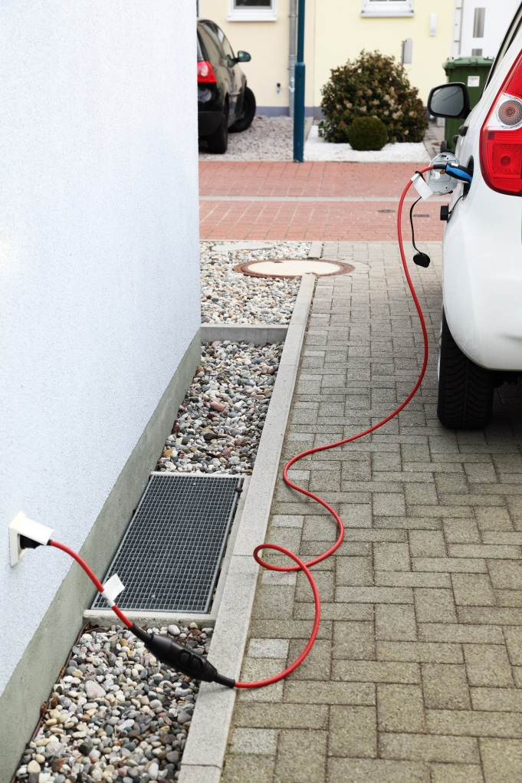

Student worksheet

4.7 Science as a human endeavour: Green jobs will increase in the future

Pages 74–75

Green jobs

The images below show different people working in green jobs.

Choose one of the green jobs: think about what the job may be and imagine that you are the person performing that job. Use the green job profiles as a guide, apply your understanding of resources that you have gained during this chapter and undertake further research online to complete the following questions.

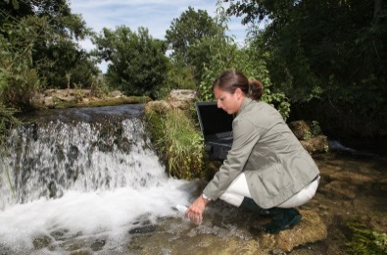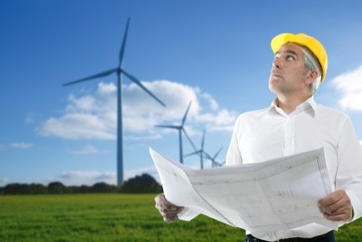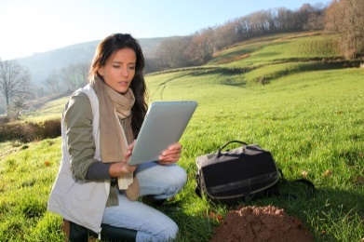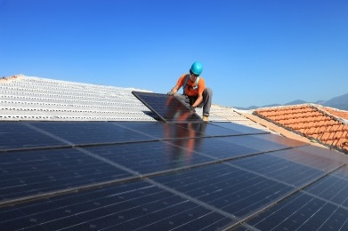

1 My typical day at work:

2 Why I love my job:

3 Worst thing about my job:

4 Skills, courses or training I needed for my job:

5 The ways my job helps the environment in the future:

EXTEND YOUR UNDERSTANDING

6 Each year, Newsweek magazine publishes its list of the top 10 green companies in the world. In 2015, an American company by the name of Biogen took first place in the rankings. Conduct research on the Internet and answer the following questions.

a What kind of company is Biogen? What does it produce?

b List three areas Biogen has invested in to become carbon neutral.

c In what year did Biogen become carbon neutral for the first time. What does this actually mean?

d Watch the video on the Biogen website (under ‘Environmental sustainability’). The Vice President of the company talks about the importance of being a ‘good corporate citizen’. What does he mean by this?